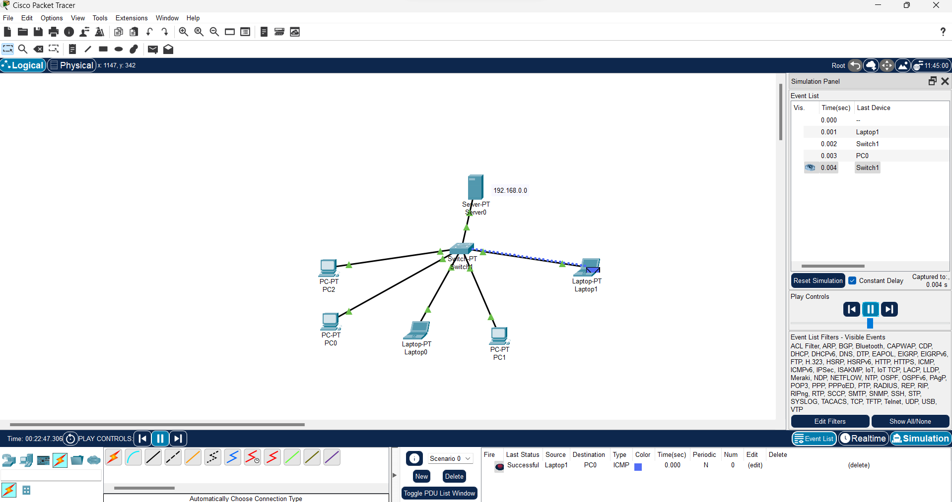**Practical11 :- Installing and configuring DHCP server and assign IP addresses to client machines using DHCP server.**

**Practical 12 :- Write a program for DNS lookup. Given an IP address input, it should return URL and vice versa.**